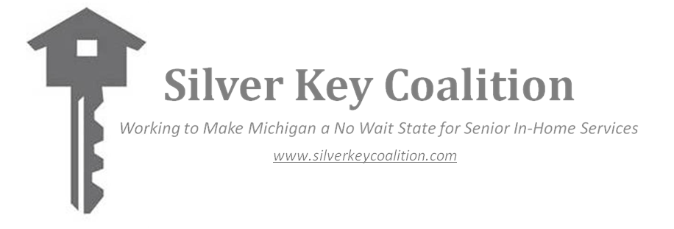
Making Michigan a No Wait State
Testimony the Silver Key Coalition
Health and Human Services Subcommittee
March 3, 2016

My name is Jim McGuire and I am the Director of Research, Policy Development and Advocacy at the Area Agency on Aging 1-B (AAA 1-B) which serves, Livingston, Macomb, Monroe, Oakland, St. Clair and Washtenaw Counties. I am speaking to you today with my Coalition colleagues from across the state as the Steering Committee Chair of the Silver Key Coalition (SKC) which was founded to advocate for state support for senior in-home services (IHS) provided through the Aging and Adult Services Agency (AASA).

The SKC consists of over 40 service agencies that deliver key in-home services such as meals on wheels, personal care, housekeeping, chore, and caregiver respite, that help physically frail older adults remain living independently in their homes for as long as possible. We are the boots on the ground organizations that are working to achieve the goal of making Michigan a no wait state for senior in-home services. We are requesting a $5 million increase in FY 2017, which will allow us to deliver services to the 7,000 seniors on AASA wait lists today.

I would like to share the Value Proposition that AASA in-home services offer to seniors and taxpayers. Seniors who have limitations in their ability to perform necessary activities of daily living, and who go without needed help because they cannot afford to pay for needed services at private market rates, often deteriorate and end up costing more in heath and public services. A recent study in southeast Michigan found that those who languished on wait lists and never got help were five times more likely to enter a nursing home than their counterparts who went on a wait list but did receive services. They also had a much higher mortality rate. And they extracted a significant burden on their family caregivers. Three out of four caregivers whose loved one got no help reported that their caregiving responsibilities interfered with their ability to work. Only one in four caregivers who received AASA services reported that caregiving interfered with work.

You should know that your aging network is not depending just on state funds to address the unmet needs of older Michiganians. The $5 million increase we are requesting will be used to leverage additional federal and local dollars, as well as cash contributions from the service recipients who contribute in accordance with their ability to pay. In addition, we are working to develop and improve new strategies to reduce and eliminate wait lists, such as by educating those who can afford to pay about private pay options, increasing the efficiency of our service delivery so that available dollars can provide more service, and testing public private partnership innovations.

We recognize that you have difficult choices to make in the budget process. Please remember that there more seniors than there are school age children in Michigan, over 2 million Michigan seniors, and the senior population is the only age group that is growing. The first baby boomers are now entering their 70’s. In the 1940’s, 50’s and 60’s we built thousands of new schools to accommodate the needs of this generation. We should not plan to again build more institutions to meet their needs, and access to in-home services can prevent this from happening. The most costly AASA service recipients are those who, based on their functional ability, qualify for nursing home care. In 2014 Michigan’s Aging Network served these individuals at an average annual cost of under $6,000. In comparison, the average annual Medicaid nursing home expenditure that year was over $68,000.

A silver key lapel pin is attached to the handout you received. We hope that you will wear it to show your support for our mission.

Respectfully submitted by:

Jim McGuire
Director of Research, Policy Development and Advocacy
Area Agency on Aging 1-B
Chair, Silver Key Coalition Steering Committee
jmcguire@aaa1b.com
(248) 262-9216

